**KENT SCHOOLS ATHLETICS ASSOCIATION**

**ESAA RACE WALKS CHAMPIONSHIPS 2024**

***NOMINATION DETAILS***

**Northwood Stadium, Stoke on Trent**

**SATURDAY 21st SEPTEMBER 2024**

**Distances:-**

**U13 (Y6/7) Development 1500m race**

**JB/JG (Y8/9) New Distance of 2000m**

**IB (Y10/11) New Distance 3000m**

**IG (Y10/11) 3000m**

**SB/SG (Y12/13) New Distance 3000m**

**Please complete and return to me asap**

**Name:…………………………………………………….. Date of birth:…………**

**Age Group:...................................................................................................................**

**Address:…………………………………………………..**

**……………………………………………. Post Code:…………………….**

**Tel. No:……………………………………………………**

**Email:…………………………………………………………………………………...**

**School Name:…………………………………………………………………………..**

**School Address:……………………………………………….**

**……………………………………Post Code:……………………….**

**Have you represented Kent School’s before YES NO**

**Are you available on Saturday 21st September YES NO**

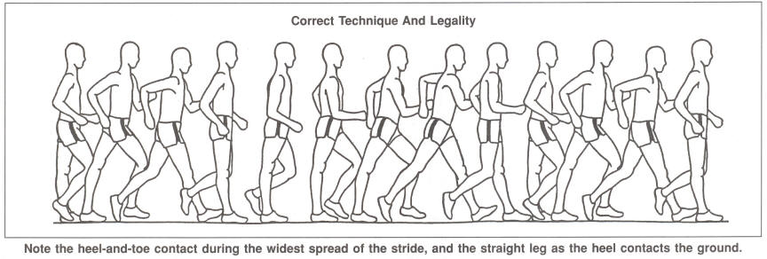

**Please return completed form to:**

**IAIN PRESNELL**

**23 SWEEPS HILL CLOSE**

**PEMBURY**

**KENT. TN2 4LT**

**ijkl.presnell@btopenworld.com**